Section b: Curriculum vitae

Personal info  Family name, First name: Makk, Péter  Researcher ID: ORCID - 0000-0001-7637-4672  Birth: 09.02.1983. Székesfehérvár, Hungary  Nationality: Hungarian  URL for web site: https://nanoelectronics.physics.bme.hu/ | 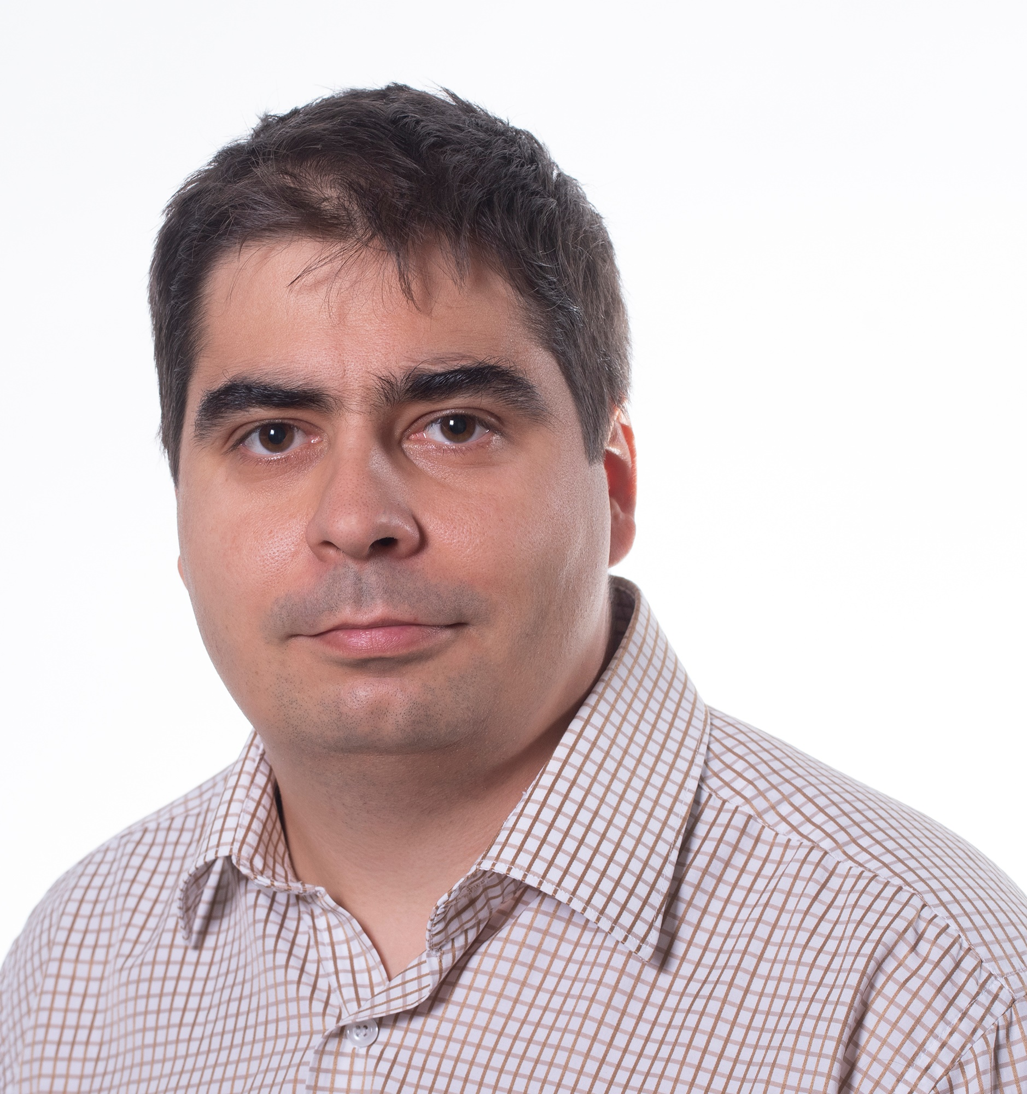

Education
• PhD in Physics, 2012, Budapest University of Technology and Economics (BME), Hungary
Dept. of Physics, supervisor: Prof. András Halbritter, Summa Cum Laude
PhD work: Investigation of molecular nanocontacts beyond conductance histograms
• MSc in Physics, 2007, Budapest University of Technology and Economics (BME), Hungary
Master thesis: Investigation of molecular nanocontacts with MCBJ technique
Current position
2019 - Associate professor, BME
2021 - Momentum group leader
Previous positions
2018-2020 Marie Curie fellow, Dept of Physics, BME
2017–2018 Scientific co-worker, BME, Department of Physics, Hungary
2012–2013 SCIEX fellow (prestigious Swiss postdoctoral grant)
2012–2017 postdoctoral fellow, University of Basel (UniBas), Department of Physics, Switzerland
2010–2012 scientific co-worker, Hungarian Academy of Sciences
scientific co-worker, BME, Department of Physics, Hungary
Languages
• English – fluent, German – intermediate, French – basic, Hungarian – mother tongue
Awards/fellowships
2021 Bolyai Memorial plaquette from the Hungarian Academy of Sciences
2021 Gyulai Prize from the Hungarian Physical Society
2018 Marie Curie Fellowship
2017 Bolyai Fellowship from Hungarian Academy of Sciences
2012 Sciex postdoctoral fellowship
2010 2nd place at University Research Grant
2007 3rd place at the National Scientific Students Associations Conference
2006 Excellent Student of the Faculty Award, BME
2006 University Award, BME
Supervision of students
• 2 PhD students (Bálint Szentpéter, Máté Kedves, ongoing), BME
• Co-supervision of 6 PhD students at UniBas (Matthias Brauninger, Peter Rickhaus, Clevin Handschin, Simon Zihlmann, Lujun Wang, David Indolese), 2 PhD (Endre Tóvári, Bálint Fülöp) at BME
• 3 BSc (Tamás Pápai, Máté Büki, Tamás Kalmár), 3 MSc (Bálint Szentpéteri, Máté Kedves, Tamás Pápai - ongoing), BME
Teaching activity
• Quantum computing architectures (2018, 2020, BME).
• Organizer of Journal club meetings (2013–2022, UniBas, BME).
• Introduction to nanophysics (2011, 2018-2021, BME).
• MSc laboratory (2018, 2019 BME).
• Quantum transport lecture (2016, 2017 UniBas).
• Quantum mechanics exercise (2015, 2016, UniBas).
• Nanophysics proseminar (2013-2015, UniBas).
• Transport in complex nanostructures (2010–2013, 2019, BME).
• Condensed matter physics laboratory (2007–2011, BME).
• Condensed matter exercises (2008–2010, BME, 2013–2014, UniBas).
Grants (as PI):
• FlagERA network 2DSOTECH, 2Dimensional van der Waals Spin-Orbit Torque Technology, 2022-2025, 140 kEUR
• Momentum Grant, most prestigious research grant from the Hungarian Academy of Sciences, 700 kEUR, Tuning synthetic correlated phases in van der Waals heterostructures, 2021-2026
• Marie Curie Grant (Topograph), 2018-2020, 146 kEUR
• Bolyai Fellowship, Ballistic graphene nanocircuits, 13 kEUR, 2017-2020, evaluated “excellent”
• FlagERA network TopoGraph – consortium leader - Engineering topological superconductivity in graphene, EU Commission, NKFIH), 2017-2022, 560 kEUR
• OTKA FK123894, Ballistic electron transport in low dimensional nanostructures, NKFIH, 2017-2021, 115 kEUR, evaluated excellent
• OTKA PD121052 “Ballistic electron transport in hybrid nanostructures“ research fund from Hungarian Science Fund, 2016-2018, 27kEUR
• Bolyai scholarship from the Hungarian Academy of Sciences, 2015, 13kEuro, not started due to going abroad
• Paul Scherrer Institute, SLS beam-time grant, 2014
• Sciex postdoctoral fellowship from the Swiss government, 2012, 80kCHF
Community service
• Reviewer: in Nature, Nat. Nano, Nat. Phys., PRL., Nano Lett., PRB, 2D Mat., PSSB, etc.
• Member of scientific societies: Hungarian Physical Society, member of the public body of Hungarian Academy of Sciences, Member of the Hungarian Astronomical Union
• Grant reviewer: Slovak Academy of Science, ANR
• Organization of workshops: the International graphene and vdW student workshop for 5 times (4 times in Basel, 1 in Budapest)
• A world of correlation – in memory of Alfred Zawadowski, member of organizing committee ~ 100 participants (Budapest, 2019)
• Organizer of nanoelectronics seminar at BME
• Member of the admission committee at BME
Major international collaborators relevant to the proposal include
• Prof. Kenji Watanabe, Prof. Takashi Taniguchi (NIMS, J – hBN growth), • Prof. Christian Schönenberger (transport in 2D materials, Uni. Bas., CH), • Prof. Klaus Ensslin (Transport in twisted graphene structures, ETH Zürich, CH), • Prof. Dimitri Efetov (transport in superlattices, LMU, D), • Prof. Jeanie Lau (transport in vdW structures, Ohio State Uni., US) •Prof. Srijit Goswami (QTech, NL – graphene superconductor devices), • Prof. Klaus Richter (Uni. Regensburg, D – theory of graphene transport), • Prof. Bart van Wees and Dr. Marcos Guimaraes (Uni. Groningen, NL – graphene spintronics), • Prof. Pablo San-Jose (Madrid, S – Theory of topological states), • Prof. Richard Warburton (Uni. Bas., CH – optics in 2D materials), • Prof. Justin Ye (Groningen, NL - TMDCs), • Prof. Saroj Dash (Chalmers, SE - graphene spintronics), • Prof. Jaroslav Fabian (Regensburg, D – spintronics theory)
Conferences
Talks, invited talks and posters in more than 20 conferences, including
• Graphene Week, Spintech, Condensed Matter in Paris, International Winterschool on
Electronic Properties of Novel Materials, CMD2020GEFES, Frontiers in Quantum Engineered Devices,
International conference on molecular electronics, Moriond: Quantum Transport in Nanophysics, GM2016 international conference
Non-conference talks:
• Meeting of the Physical Society, MAFIHE/IAPS Summerschools on Nanophysics, Swiss Nanoscience Institute annual meeting, Annual meeting of the Hungarian Academy of Sciences, BME Science Camp summer school, BME Science Campus
Membership and representation of the research group in several research networks
• 2021-2025 2DSOTech FlagERA network (BME), 2021-2025 SuperGate FET open network (BME), 2019-2023 AndQC FET open network (BME), 2018-2022 SuperTop QuantERA network (BME), 2018-2022 Topograph Flagera network (Coordinator), 2016-2019 iSpinText Flagera network (UniBas, BME), 2012-2017 Quantum Science and Technology Network, QSIT-NCCR (UniBas), 2013-2018 Graphene Flagship, Spintronics WP (UniBas), 2014-2016 Swiss two-dimensional material meetings (UniBas), 2012-2014 EU research network SE2ND (BME and UniBas), 2010-2012 EU research network FunMols (BME).

Publications
The PI has total of 59 (44 without PhD supervisor) published peer-reviewed manuscripts, h-index of 20 (23) with 1150 (1600) total number of citations according to Scopus (G.Scholar), with a cumulative impact factor/average impact factor: 480/8.1. These manuscripts include 1 Nature Nanotechnology, 2 Nature Communications, 14 Nano Letters, 6 PRLs, 10 PRBs, etc. For up to date publication list please check Scopus or Google Scholar.
Selected publications (all without PhD supervisor)

- B. Szentpéteri, P. Rickhaus, F. K. de Vries, A. Márffy, B. Fülöp, E. Tóvári, K. Watanabe, T. Taniguchi, A. Kormányos, Sz. Csonka, and P. Makk, Tailoring the Band Structure of Twisted Double Bilayer Graphene with Pressure, Nano Letters, 21, 8777 (2021), Measurements showing the large tunability of twisted graphene structures with pressure
- B. Fülöp, A. Márffy, S. Zihlmann, M. Gmitra, E. Tóvári, B. Szentpéteri, M. Kedves, K. Watanabe, T. Taniguchi, J. Fabian, C. Schönenberger, P. Makk, Sz. Csonka, Boosting proximity spin orbit coupling in graphene/WSe₂ heterostructures via hydrostatic pressure, npj 2D Materials and Applications 5, 82 (2021), PI was co-supervisor of this project. First demonstration of increased proximity effect by pressure, CA
- L. Wang, P. Makk, S. Zihlmann, A. Baumgartner, D. Indolese, K. Watanabe, T. Taniguchi, C. Schönenberger, Mobility Enhancement in Graphene by in situ Reduction of Random Strain Fluctuations, Phys. Rev. Lett., 124, 157701 (2020), the PI was a supervising postdoc, CA
- L. Wang, S. Zihlmann, M.H. Liu, P. Makk, K. Watanabe, T. Taniguchi, A. Baumgartner, C. Schönenberger, New Generation of Moiré Superlattices in Doubly Aligned hBN/Graphene/hBN Heterostructures, Nano Letters, 19, 2371 (2019), First demonstration of double-superlattice, PI was project supervising postdoc
- L. Wang, S. Zihlmann, A. Baumgartner, J. Overbeck, K. Watanabe, T. Taniguchi, P. Makk, C. Schönenberger, In Situ Strain Tuning in hBN-Encapsulated Graphene Electronic Devices, Nano Letters 19, 4097 (2019), the introduction of new straining method, PI co-guided the project, CA
- J. G. Roch, G. Froehlicher, N. Leisgang, P. Makk, K. Watanabe, T. Taniguchi, C. Schönenberger, R. J. Warburton, Spin-polarized electrons in monolayer MoS2, Nature Nanotechnology 14, 432 (2019), First demonstration of magnetism in MoS2
- D. Indolese, R. Delagrange, P. Makk, J.R. Wallbank, K. Wanatabe, T. Taniguchi, C. Schönenberger, Signatures of van Hove Singularities Probed by the Supercurrent in a Graphene-hBN Superlattice, Phys. Rev. Lett. 121, 137701 (2018), SC currents induced to the superlattice used to extract the DOS
- S. Zihlmann, A.W. Cummings, J.H. Garcia, M. Kedves, K. Watanabe, T. Taniguchi, C. Schonenberger, P. Makk, Large spin relaxation anisotropy and valley-Zeeman spin-orbit coupling in WSe2/graphene/h-BN heterostructures, Phys. Rev. B, 97, 075434 (2018) First detection of spin relaxation anisotropy via low-T quantum transport measurements
- C. Handschin, P. Makk, P. Rickhaus, M.-H. Liu, K. Watanabe, T. Taniguchi, K. Richter, C. Schönenberger, Fabry-Pérot resonances in a graphene/hBN Moiré superlattice, Nano Letters 17, 328 (2017), First study used to confine electrons in cavity using superlattice. PI was the Postdoc guiding the work, CA
- P. Rickhaus, P. Makk, M.-H. Liu, E. Tóvári, M. Weiss, R. Maurand, K. Richter, C. Schönenberger, Snake trajectories in ultraclean graphene p-n junctions, Nature Communications 6, 6470, (2015), First paper demonstrating snake states in graphene. PI was the supervising postdoc and shared first author
CA: Corresponding author
Awards/fellowships (selection, see full list at CV)
2018 Marie Curie Fellowship
2017 Bolyai Fellowship from the Hungarian Academy of Sciences
2012 Sciex postdoctoral fellowship
Conferences (see details at CV)
Talks, invited talks and posters in more than 20 conferences, including
• Graphene Week, Spintech, Condensed Matter in Paris, International Winterschool on
Electronic Properties of Novel Materials, CMD2020GEFES, Frontiers in Quantum Engineered Devices,
International conference on molecular electronics, Moriond: Quantum Transport in Nanophysics, GM2016 international conference
Organization of international workshops/conferences
• Initiator and organizer of Graphene and 2D heterostructures workshop, including several leading graphene research groups in Europe, 4 times in Basel (2015, 2016, 2017, 2021) and once in Budapest (2019), ~40-50 participants each time
• Topological phases in van der Waals heterostructures workshop, ~25 participants, (Budapest, 2018)
• A world of correlation – in memory of Alfred Zawadowski, member of organizing committee ~ 100 participants (Budapest, 2019)

